QORVO_RADIO Final Report Research

Terminology:
FPGA: Field Programmable Gate Array
SDR: Software Defined Radio
SMA: Connector interface for coaxial cable
LNA: Low Noise Amplifier
LO: Local Oscillator
RF: Radio Frequency
ADC: Analog to Digital Converter
I/O: Input/Output

Standards QORVO_RADIO Team Used:
- IEEE Std 1990.1-2019 – section 3.9 for a software-defined radio.
- IEEE Std 287.1-2021 for coaxial connections
- IEEE Std 802.3 for USB port
- IEEE Std 1641-2022 Testing methods

QORVO_RADIO Team Specs:
- Tuning range of 85-2500MHz for 2 receiver paths
- Weigh less than 20lbs
- Qualify for carry-on luggage
- Communicate with the PC using USB 2.0 or better
- 2 Receive (Rx) channels
- Minimum 40MHz Bandwidth.
- 2x SMA Interfaces to connect antennas or other modules
- Room for power additional power supply
- Circuit design to account for future use
- FPGA modular

QORVO_RADIO Performance Verification:
- Using a transceiver SDR (off-shelf) to test our receiver’s (SDR) range from 85 - 2,500 MHz
- The interface between the SDR platform and a PC will be tested by connecting the platform to a PC, verified by successful control commands and data transfer, to confirm reliable communication between the two devices.
- The functionality of the platform’s dual Receive channels will be tested by simultaneously receiving and processing signals on both channels. Which will confirm the device meets the requirement of being multi-channel operational.
- Bandwidth will be tested by evaluating the signal processing performance across a 40 MHz bandwidth.
- The SMA interfaces (PS7) will be verified by connecting RF equipment and confirming there is successful data transfer and stable connections.

Front End Design:
The front end module must handle a wide tuning range of 85-2500MHz, a 50MHz instantaneous bandwidth, and high signal fidelity while maintaining noise and distortion. The FPGA-based SDR platform must support multiple modules.

Block diagram for front end module:
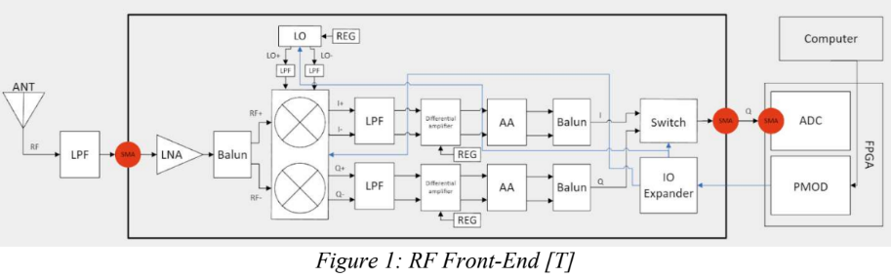

Signal begins at the antenna, captures the RF signals and passes them to the LNA. The LNA amplifies the signal while maintaining low noise.
The TC1-1-13M+ Balun converts the amplified signal to a differential signal, preparing the signal for the mixer.
The Mixer takes the differential signal and down converts it to baseband I/Q signals through quadrature demodulation. Quadrature demodulation simplest the signal chain by avoiding an intermediate frequency stage. This ensures efficient and direct processing of the baseband signals.
Mixer operates off of a reference frequency proved by the LO. The LO determines the frequency to which the RF signal is converted. This reference frequency ensures accurate down conversion which enables the SDR to tune seamlessly across the wide operational bandwidth.
The I and Q output of the mixer are filtered using custom low-pass filters and anti-aliasing filters to reject out of band noise.
The LTC6409 differential amplifier provides a low distortion amplification and buffer. This further optimizes performance.
The filtered I/Q signals from both high and low-band mixers are routed to the ADG736 switch. This switches the appropriate channels to pass to the SMA outputs. These outputs are connected directly to the ADC, which digitizes the signals for processing within the FPGA.
The SDR utilized an I/O expander to extend the limited I/O capabilities of the FPGA by providing an additional 16 general purpose I/O pins. These pins are primarily used to control various chips and the analog switch utilizing the FPGA’s SPI protocol.

SDR Power:
The SDR utilizes a Bel Power solutions HCC512-AG linear AC-DC converter that provides dual outputs of 5V 6A and 12V 2.5A. The linear power supply delivers clean and stable power with minimal noise, crucial for RF applications.
Voltage regulators are used to step down the power supply voltages to the specific levels required by various components in the SDR. Low noise and precise regulators we chosen.

PCB Design:
The PCB was designed using Altium following best practices to ensure optimal performance.
The PCB was separated into 6 layers to minimize interference and maintain signal integrity in the high-frequency front end. Dedicated layers for critical signals, power distribution, control lines, and dedicated grounding was designed.
Shielding was implemented for crucial components such as the LNA, mixer, and LO to protect signal integrity from external and internal noise.

FPGA Design:
The Zynq 7000 series was chosen as it met the project requirements of high speed data processing, ability to cover wide frequency ranges, and flexibility for future expansion. The Zynq is commonly used in SDR applications.
The Eclypse Z7 FPGA board was paired with the Zmod SDR ADC, this allows the use of one of the Eclypse Z7’s dual Zmod high speed ports, leaving room for a spare port.
This FPGA/SDR systems allows the following softwares to interface with the systems: SDR#, SDR++, HDSDR, and GNU Radio. GNU radio was chosen due to its versatility and ease of use.

Enclosure Design:
The enclosure's base plate was made of aluminium that can be used as a ground.
The current enclosure is designed to hold a second PCB for QORVO_RADIO2.

Further Notes:
Instantaneous Bandwidth (IBW) is the range of frequencies at a given time that can be transmitted through a communication channel.
Baseband I/Q signals stand for In-Phase(I) and Quadrature(Q), which are two signals of the same frequency that are 90 degrees out of phase.
“The operation principle of the quadrature demodulator is based on the sequential allocation of the frequency components of the input signal by multiplying it with two orthogonal harmonic signals.”
“The maximum frequency component a sampled data system can accurately handle is its Nyquist limit. The sample rate must be greater than or equal to two times the highest frequency component in the input signal. When this rule is violated, unwanted or undesirable signals appear in the frequency band of interest. This is called "aliasing."”

Sources:
L. Cohen and C. Lee, "Instantaneous bandwidth for signals and spectrogram," International Conference on Acoustics, Speech, and Signal Processing, Albuquerque, NM, USA, 1990, pp. 2451-2454 vol.5, doi: 10.1109/ICASSP.1990.116086.

https://www.everythingrf.com/community/what-are-i-q-signals

A. N. Serov, N. A. Serov and S. I. Gerasimov, "Application of the Quadrature Demodulation for the Measurement of Electric Power Parameters," 2019 18th International Symposium INFOTEH-JAHORINA (INFOTEH), East Sarajevo, Bosnia and Herzegovina, 2019, pp. 1-6, doi: 10.1109/INFOTEH.2019.8717784.

https://www.analog.com/en/resources/technical-articles/guide-to-antialiasing-filter-basics.html

